H
H |  |  | NANYANG JUNIOR COLLEGE  JC 2 PRELIMINARY EXAMINATION  ANSWERS  Higher 2
CHEMISTRY |  |  |  |  |  |  | 9647/03
Paper 3 Free Response |  |  |  |  |  |  | 14 September 2010
 |  |  |  |  |  |  | 2 hours
Candidates answer Section A on the Question Paper

Additional Materials: Answer Paper
Data Booklet

READ THESE INSTRUCTIONS FIRST
Write your name and class on all the work you hand in.
Write in dark blue or black pen on both sides of the paper.
You may use a soft pencil for any diagrams, graphs or rough working.
Do not use staples, paper clips, highlighters, glue or correction fluid.

Answer any four questions.
A Data Booklet is provided.
You are reminded of the need for good English and clear presentation in your answers.
At the end of the examination, fasten all your work securely together.
The number of marks is given in brackets [ ] at the end of each question or part question.
Section B  Answer all questions on separate answer paper. |  |  |  |  |  |  |  |  |  | For Examiner’s Use
 |  |  |  |  |  |  |  |  |  | Section A
 |  |  |  |  |  |  |  |  |  | 1
 |  |  |  |  |  |  |  |  |  | 2
 |  |  |  |  |  |  |  |  |  | 3
 |  |  |  |  |  |  |  |  |  | 4
 |  |  |  |  |  |  |  |  |  | 5
 |  |  |  |  |  |  |  |  |  | Total
This document consists of 10 printed pages and 0 blank page.

Answer any four questions.

1 Hydrogen iodide is a colourless gas with a suffocating smell. It can be formed by reacting hydrogen and iodine.

(a) (i) Write an equation for the reaction between hydrogen and iodine. [1]

I₂(g) + H₂(g) 2HI(g)

(ii) Hydrogen chloride can also be formed by reacting hydrogen and chlorine. Compare the reactions of chlorine and iodine with hydrogen. [2]

Cl₂ reacts explosively with hydrogen.
An equilibrium is established when I₂ reacts with hydrogen

H−Cl bond formed is the strongest hence HCl formed is very stable and readily formed. H−I bond formed is the weakest, thus when HI is formed, it readily decomposed. Hence the reaction between H₂ and I₂ is the slowest and reaches equilibrium.

(b) At 400ºC, 0.4 mol of hydrogen and 0.4 mol of iodine are introduced into a reaction vessel containing platinum catalyst. The “filmstrip” below represents five molecular scenes, A to E of the reaction of hydrogen and iodine over time. Each particle in the “filmstrip” represents 0.1 mol.

A
B
C
D
E
H atom
l atom
We can find out whether the above reaction mixture is proceeding toward the equilibrium state by calculating the reaction quotient, Q at each scene. The expression for Q is the same as that for the equilibrium constant, K_{c}. Equilibrium is reached when Q approaches a constant value.

(i) Write the expression for the reaction quotient, Q, for the reaction of hydrogen and iodine. [1]

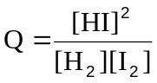

(ii) Calculate the value of Q for each scene, A to E. Explain how these calculations show that the reaction mixture is at equilibrium in scene E. [3]

A: Q = 0
B: 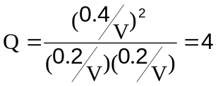
C, D & E:
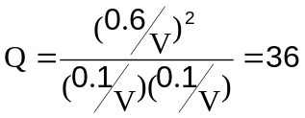
From the calculation above, it can be seen that Q approaches a constant value as the reaction progress to scene E. [1] Thus the reaction mixture has reached equilibrium at scene E.

(iii) Hence, state the value of K_{c} for the reaction of hydrogen and iodine at 400ºC.
[1]
36

(iv) The reaction mixture in scene E is heated to 550ºC. This caused 50% of the hydrogen iodide present to decompose. Calculate the value of K_{c} at 550ºC.
[2]

I₂(g) + H₂(g) 2HI(g)
Initial amt/mol 0.1 0.1 0.6
Change in amt/mol +0.15 +0.15 -0.3
Equim amt/mol 0.25 0.25 0.3
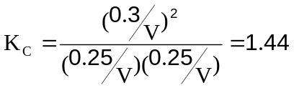

(v) Using your answers in (b)(iii) and (iv), deduce the sign of the enthalpy change of reaction of hydrogen and iodine. [2]

As temperature increases, K_{c} decreases. By LCP, an increase in temperature favored the endothermic reaction. Since K_{c} decreases, POE lies to the left. The backward reaction is endothermic, thus the reaction between hydrogen and iodine which is the forward reaction is exothermic. The sign of the enthalpy change of reaction of hydrogen and iodine is negative.

(vi) Explain how the amount of hydrogen iodide will change when the reaction mixture in scene E is compressed. [2]

The amount of hydrogen iodide will remained unchanged. As the mole ratio of the reactants to the products is 1:1, the equilibrium is not affected by changes in pressure.

(c) (i) Using the following data, and relevant data from the Data Booklet,
construct an energy level diagram to calculate the standard enthalpy change for the following reaction.

HCl(g) → H⁺(g) + Cl⁻(g)

Enthalpy change of formation of HCl(g) = −92 kJ mol⁻¹
Electron affinity of Cl(g) = −364 kJ mol⁻¹ [4]

H(g) + Cl–(g)
Energy
1st IE (H) + 1st EA (Cl)

H(g) + Cl(g)
½ BE(H−H) + ½ BE(Cl−Cl)
ΔH_{rxn}

½H₂(g) + ½Cl₂(g)
0
ΔH_{f} (HCl)
HCl (g)

ΔH_{rxn} = − ΔH_{f} (HCl) + ½ BE(H−H) + ½ BE(Cl−Cl) + 1st IE (H) + 1st EA
ΔH_{rxn} = −(−92) + ½(436) + ½(244) + 1310 + (−364)
ΔH_{rxn} = + 1378 kJ mol⁻¹

(ii) Explain the difference between your answer from (c)(i) with the standard enthalpy change for the process shown below.
HCl(g) + aq → H⁺(aq) + Cl⁻(aq) ΔH = −75 kJ mol⁻¹ [2]

[Total: 20]

Reaction 2 involves forming ion-dipole interactions between H⁺ and water molecules and Cl⁻ and water molecules. Energy is evolved in the formation of ion-dipole interactions which can more than compensate the heat absorbed to break the H−Cl bond in the gaseous state and to ionise the H atom, thus resulting in the enthalpy change of reaction 2 to be exothermic.

2(a) Two common qualitative analysis tests are used to differentiate between the different classes of alkyl halides.

Alcoholic silver nitrate test
When silver nitrate is added to an alkyl halide in ethanolic conditions, a silver halide precipitate may form after some time:
AgNO₃ + RX + C₂H₅OH ⎯→ ROC₂H₅ + HNO₃ + AgX(s)

Sodium iodide / propanone test
When sodium iodide in propanone is added to an alkyl halide (chloride or bromide), a sodium chloride or sodium bromide precipitate may form after some time:
NaI + RCl ⎯→ RI + NaCl(s)
NaI + RBr ⎯→ RI + NaBr(s)

These two tests were performed on a series of alkyl halides and the results are tabulated below:
Expt | Alkyl Halide | Time taken for precipitate to appear in silver nitrate test | Time taken for precipitate to appear in sodium iodide test
1 | 1-bromobutane | 5 min | 1 min
2 | 2-bromobutane | 3 min | 13 min (with heating)
3 | 2-bromo-2-methylpropane | 1 min | No ppt

- Due to the conditions used, alkyl halides react predominantly by S_{N}1 mechanism in the silver nitrate test. However they react by predominantly S_{N}2 mechanism in the sodium iodide test.

By considering the structure of the alkyl halides used in the tests above, explain why the test results confirm this statement. [3]

- 3° alkyl halide (2-bromo-2-methylpropane) reacted fastest in the AgNO₃ test while it hardly showed any reaction in NaI test.
- 1° alkyl halide (1-bromobutane) reacted slowest in AgNO₃ test while it reacted the fastest in NaI test.
1 mark for observation
- 3° alkyl halides form stable carbocations and tend to react via S_{N}1 mechanism, which can be seen from its fast reaction in the AgNO₃ test. [1]
- On the other hand, there is a great amount of steric hindrance caused by the 3 R groups in 3° alkyl halides, hence causing reaction via S_{N}2 mechanism to be very slow. [1]

(ii) Describe the mechanism of the reaction in the silver nitrate test with 2-bromobutane. [2]

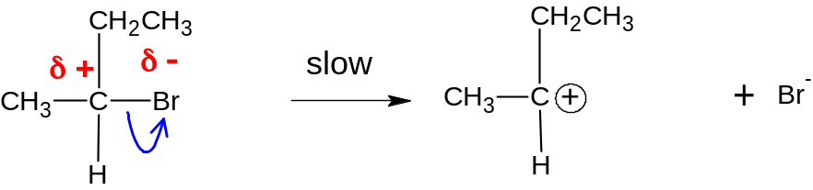
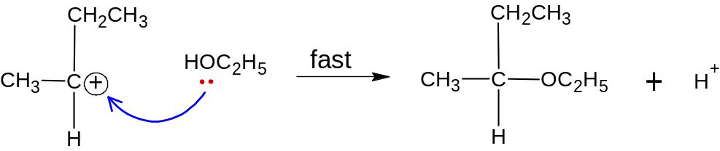
1 mark – correctly balanced fast and slow steps (not necessary to show how H⁺ is extracted from the resulting compound)
1 mark – arrows, dipoles and movement of electrons

(iii) If the sample of 2-bromobutane used was optically pure and rotated plane-polarised light by +89°, what kind of optical activity would you expect to observe with the resulting compound after reacting with ethanolic silver nitrate? Explain your answer. [2]

- Resulting compound does not rotate plane polarized light.
- Nucleophile attacks the planar carbocation from either sides, forming equimolar amounts of enantiomers. Hence a racemic mixture is formed.

(iv) Draw a reaction pathway diagram of the mechanism you described in (a)(ii). [2]
Energy / kJ mol⁻¹
CH₃CHBrCH₂CH₃
CH₃C⁺HCH₂CH₃
CH₃CH(OC₂H₅)CH₂CH₃
Ea₂
Ea₁
Reaction pathway

Marking points:
- Axes are correctly labeled
- Reactant, intermediate and products are correct
- Shape of curve is correct (Ea1 > Ea2)

(v) Predict the time taken for precipitation to form, if any, when the sodium iodide test was separately performed on 1-chlorobutane and ethanoyl bromide. Explain your answer. [4]
For 1-chlorobutane:
- Time take for ppt to appear > 1 min.
- C-Cl bond is shorter and stronger than C-Br bond, hence less easily hydrolysed
For ethanoyl bromide:
- Ppt formed immediately
- Positive dipole on C is increased due to the highly electron-withdrawing C=O group, hence more susceptible to nucleophilic attack.

(b) Piperidine is a colourless liquid with an odour described as ammoniacal and pepper-like. It is a widely used building block and chemical reagent in the synthesis of proteins.
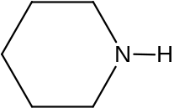
Piperidine
When piperidine is treated with an excess of iodomethane, compound R is formed. On heating with alcoholic potassium hydroxide, R reacts to form compound S, as in the following scheme.
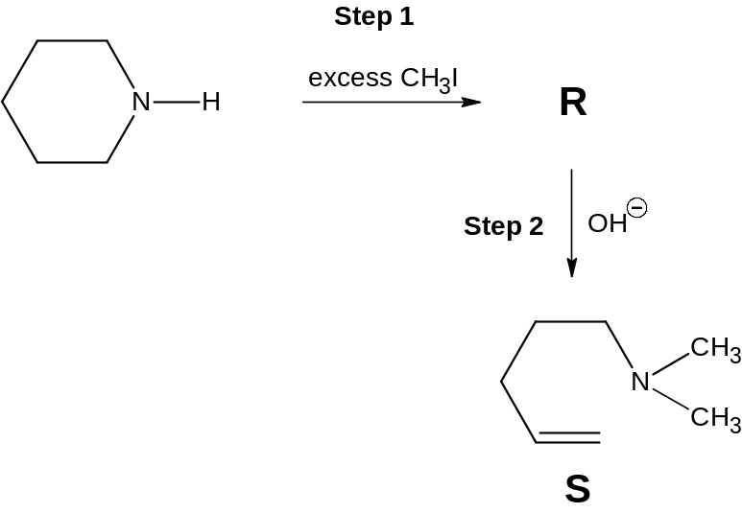

(i) Draw the structure of R. [1]

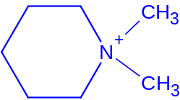
(ii) Suggest what type of reaction took place in Step 2. [1]
Elimination

(iii) Draw the structure of the compound formed when piperidine reacts with ethanoic acid. [1]
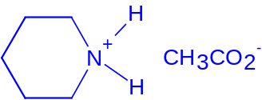

(c) Piperidine (K_{b} = 1.3 × 10⁻³ mol dm⁻³) is commonly used as a solvent and base.
(i) Sketch the titration curve for the titration of a 20.0 cm³ sample of a 0.200 mol dm⁻³ piperidine solution with 0.100 mol dm⁻³ of HCl. Label the end-point clearly. [2]
0
12
76
0
40
pH
End point
Vol of acid / cm³
114

Marking points:
- Shape of curve (dips sharply at the beginning)
- Equivalence point < 7
- Endpoint = 40 cm³

- Explain why the pH at the equivalence point of the titration in (i) is not neutral.
Support your answer with an appropriate equation. [1]

The salt that is formed hydrolyses in water to produce H⁺ ions
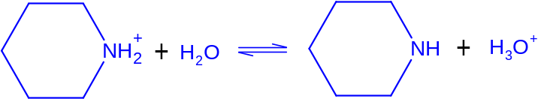
(iii) Explain why the pepper-like smell of piperidine gradually disappeared upon addition of HCl. [1]

An ionic salt is formed which has low volatility and does not give off a smell.

[Total: 20]

3 (a) (i) By means of a fully labelled diagram, describe how the standard electrode potential of the Fe³⁺/Fe²⁺ system can be measured by using a standard hydrogen electrode. [3]
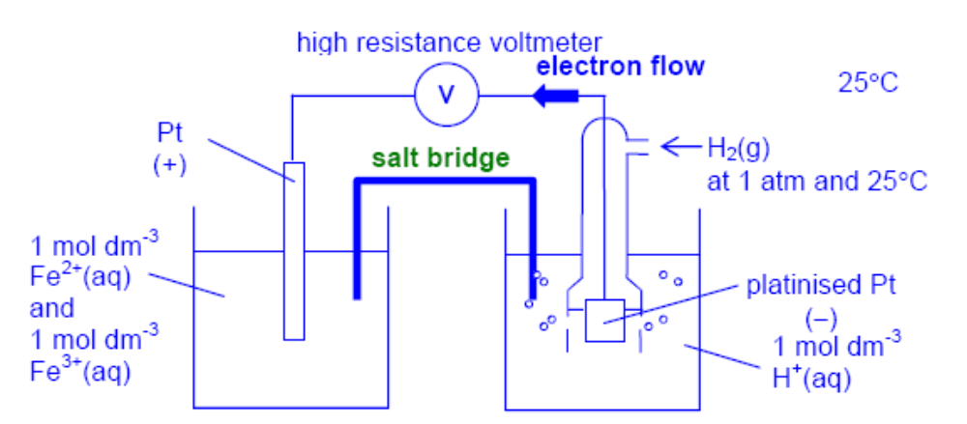
Salt Bridge
Inert electrode (x2)
Standard conditions
Fe3+/Fe2+ electrolyte
Hydrogen gas inlet

(ii) 1.00 mol dm⁻³ of acidified potassium manganate(VII) is added dropwise to the Fe²⁺/Fe³⁺ half cell. Predict and explain if the E○_{cell} would increase or decrease. [2]

Fe³⁺ + e Fe²⁺ E○ = + 0.77 V reaction (1)

E○_{cell} = E○(Fe³⁺/Fe²⁺) – E○(H⁺/H₂) = +0.77V

When H⁺/MnO₄⁻ is added dropwise to the Fe²⁺/Fe³⁺ half cell, Fe²⁺ will be oxidised to Fe³⁺.

[Fe²⁺] decreases.

By Le Chatelier’s Principle, the position of equilibrium for reaction (1) shifts right.

Hence E○(Fe³⁺/Fe²⁺) becomes more positive. [1]

E○_{cell} increases. [1]

(iii) The E○_{cell} value eventually plateau to a value x. Using relevant data from the Data Booklet, state the value of x. [1]

x = + 1.52 V
MnO₄—/Mn²⁺ system.

(b) Using relevant data from the Data Booklet, explain the following observations with relevant equations:

(i) Aqueous potassium iodide turns brown when aqueous iron(III) sulfate is added to it.
Fe³⁺ + e Fe²⁺ E○ = + 0.77 V
I₂ + 2e 2I⁻ E○ = + 0.54 V
E○ _{cell} = + 0.77 – (+0.54) = 0.23 V [1]
2Fe³⁺ + 2I⁻ → 2Fe²⁺ + I₂
• Hence the solution turns brown due to the formation of aqueous iodine. [1]

(ii) When a few drops of aqueous KCN is added to aqueous iron(III) sulfate, the solution turns orange-red. The solution remains as orange-red on addition of aqueous potassium iodide.
[4]
Ligand exchange occurs. [1] for stating.

CN⁻ ligands displace water ligands from, Fe³⁺ to form the more stable complex [Fe(CN)₆]³⁻ which is orange-red in solution.

• [Fe(H₂O)₆]³⁺ + 6CN⁻ [Fe(CN)₆]³⁻ + 6H₂O
Brown orange-red

• I₂ + 2e 2I⁻ E○ = + 0.54 V
[Fe(CN)₆]³⁻ + e [Fe(CN)₆] ⁴⁻ E○ = + 0.36 V

E○ _{cell} = + 0.36 – (+0.54) < 0 [1]

• Since the E○ _{cell} < 0, [Fe(CN)₆]³⁻ will not be able to oxidise I⁻. Hence the solution remains orange-red.

(c) Hard water, which contains high concentration of calcium, can help to slow down the corrosion of metals due to the formation of a film of white deposit which slows down the supply of dissolved oxygen in water.

The solubility of calcium hydroxide in hard water at 25ºC is 0.160 g in 100 cm³.

(i) Calculate the solubility product of calcium hydroxide. [2]

Ca(OH)₂] =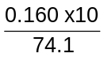 = 0.0216 mol dm⁻³ [1]

K_{sp} = [Ca²⁺][OH⁻]² = (0.0216)(2x0.0216)² = 4.02 x 10⁻⁵ mol³ dm⁻⁹
[1] for correct Ksp value and units

(ii) Calculate the approximate solubility, in mol dm⁻³, of calcium hydroxide in 0.100 mol dm⁻³ of calcium chloride solution. [2]

[Ca²⁺] in mixture = 0.100

K_{sp} = [Ca²⁺][OH⁻]² = 4.02 x 10⁻⁵

[OH⁻] = 0.0200 mol dm⁻³ [1] correct calculated [OH⁻]. Allow ecf

[Ca(OH)₂] = ½ [OH⁻] = 0.0100 mol dm⁻³ [1] for correct answer. Ecf

(d) The most common and economically destructive form of corrosion is the rusting of iron. In many ways the components of corrosion process resembles those of an electrochemical cell:

- Iron coupon functions as both anode and cathode in the rusting process.
- In the anodic region, iron behaves like an active electrode, whereas in the cathodic region, it is inactive.
- Moisture surrounding the iron functions like a salt bridge.

In the laboratory, the Ferroxyl indicator solution is commonly used to detect corrosion in iron. The Ferroxyl indicator solution is a mixture of phenolphthalein and potassium hexacyanoferrate(III), which forms a blue solid (Turnbull’s precipitate) in the presence of iron(II) ions and turns pink in the presence of hydroxide ions. These coloured regions indicate the presence of cathode and anode within the iron coupon.

iron coupon

aqueous sodium sulfate

A few drops of Ferroxyl indicator solution is added to an iron coupon immersed in aqueous sodium sulfate in the setup as shown above. A region of pink coloration is observed at Y and a blue solid is formed at Z.
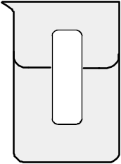
Z
Y
(i) Identify whether Y or Z is the anodic or cathodic region in the iron coupon.

Y Cathode , Z Anode [1] for correct identification
Oxidation occurs at Z rather than Y because there is a higher concentration of dissolved oxygen present at the air/electrolyte interface.

- Give the ion-electron equations at Y and Z.

Y Cathode: O₂ + 2H₂O + 4e → 4OH⁻
Z Anode: Fe → Fe²⁺ + 2e
[1] x2 for each equation. No ecf.

- Unlike iron, chromium is remarkably resistant to corrosion despite its highly negative E○ value. Chromium plating can be carried out on steel in an acidified solution of 1.0 mol dm⁻³ sodium dichromate(VI). The process is carried out on an object of surface area of 0.5 m² and the current used is 40 A. Calculate the time needed to plate the object to a thickness of 1.0 x 10⁻⁵ m.
[Density of chromium is 7.3 g cm⁻³.] [2]

[Total: 20]

Mass = density x volume = 7.3 x 0.5 x (1.0 x 10⁻⁵) x 10⁶ = 36.5 g [1]
n _{Cr} = 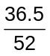 = 0.7019 mol
Cr⁺⁶ + 6e → Cr
Q = n_{e}F = It
6 x 0.7019 x 96500 = 40 x t [1]
t = 10160 s = 2.82 h [1]

4 (a) Silicon is found in Period 3 of the Periodic Table. It is the second most abundant element in the earth’s crust after oxygen.

(i) Silicon has numerous known isotopes of which ²⁸Si, ²⁹Si and ³⁰Si are stable. Given that 3.1% of naturally occurring silicon is ³⁰Si, calculate the natural abundance of ²⁸Si.

Let the abundance of ²⁸Si be x %
 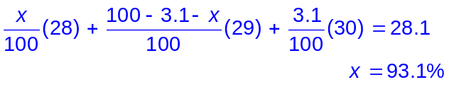
 for correct answer

(ii) Solid silicon melts at 1414 °C and is used widely industrially to manufacture computer chips. Describe the structure and bonding in solid silicon.

 Silicon has a giant covalent structure with strong covalent bonds between Si atoms.

(iii) Account for its use in computer chips.
[4]
 Silicon has low electrical conductivity hence is used as a semi-conductor.

(b) Polydimethylsiloxane (PDMS) is an organo-silicon polymer commonly referred to as silicones. It consist of an inorganic silicon-oxygen backbone (…-Si-O-Si-O-Si-O-…) with methyl side groups attached to the silicon atoms.

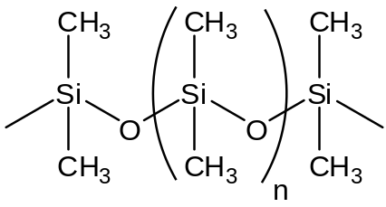
n: number of repeat units
PDMS

Simethicone is an oral anti-foaming agent used for treatment of excess gas in the stomach. It decreases the surface tension of gas bubbles, causing them to combine into larger bubbles.

Simethicone consist of a mixture of PDMS and silica gel. Silica gel is a granular form of silicon dioxide, SiO₂.

- Show by writing appropriate equations the acid-base nature of SiO₂.

SiO₂ is an acidic oxide
 SiO₂ + 2NaOH → Na₂SiO₃ + H₂O
- Suggest a property of SiO₂ that accounts for its use in Simethicone to treat stomach disorders.

 No reaction with aqueous acid.
 SiO₂ has a strong lattice structure with strong covalent bonds between Si and O atoms that makes it insoluble in water.

- The compound dimethyldichlorosilane reacts with water in a polymerisation reaction to produce PDMS.

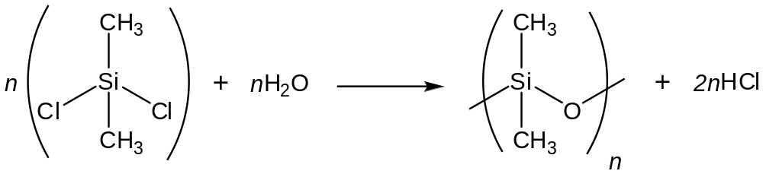
dimethyldichlorosilane

This polymerisation reaction has a ceiling temperature above which no further polymerisation can take place.

By considering, the bonds broken and bonds formed, calculate ∆H for the formation of one Si−O−Si linkage in this polymerisation reaction and use it to explain why there is a ceiling temperature in this polymerisation reaction.
[8]

 Bonds Broken Bonds Formed
Si−Cl (359 kJ mol⁻¹) Si−O (444 kJ mol⁻¹)
2 O−H (460 kJ mol⁻¹) 2 H−Cl (431 kJ mol⁻¹)

 ∆H = [359 + 2(460)] − [444 + 2(431)]
= −27 kJ mol⁻¹

 ∆S for polymerization reactions is always negative because the formation of a large molecule entails the lost of rotational and translational motion.

∆G = ∆H − T∆S
 There is a threshold temperature beyond which −T∆S > ∆H and ∆G will turn positive.
 The reaction becomes non-spontaneous when ∆G > 0.

(c) Kynurenine is an important metabolite in the biosynthesis of niacin (Vitamin B3).

Kynurenine has the molecular formula C₁₀H₁₂N₂O₃. When dissolved, an aqueous solution of Kynurenine is almost neutral and maintained its pH upon addition of small amounts of aqueous sodium hydroxide or hydrochloric acid. Addition of this solution to aqueous 2,4-DNPH caused an orange precipitate to form.

Kynurenine reacts with NaBH₄ to form compound L, C₁₀H₁₄N₂O₃. Heating L with concentrated H₂SO₄ produces only M, C₁₀H₁₂N₂O₂. Heating M with acidified KMnO₄ under reflux results in the formation of compound N, C₃H₅NO₄ and anthranilic acid.

Reaction of N with LiAlH₄ in dry ether produces compound O, C₃H₉NO₂. A solution of O turns litmus blue.

Anthranilic acid can be synthesized from methylbenzene via the following reaction pathway.

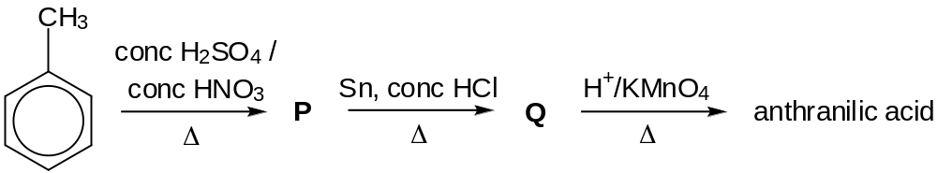

Identify the structures L, M, N, O, P, Q, anthranilic acid and Kynurenine. [8]

[Total: 20]

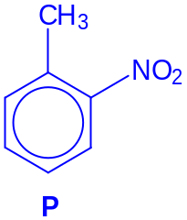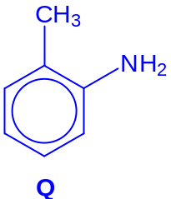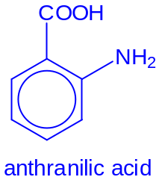

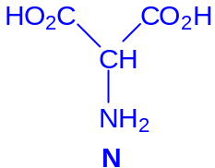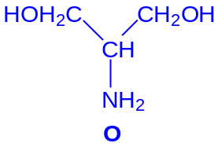

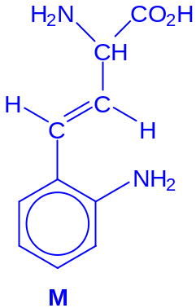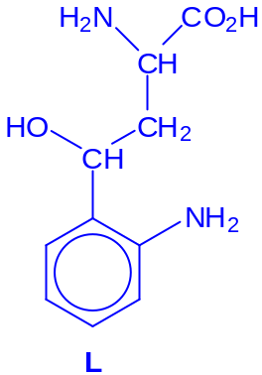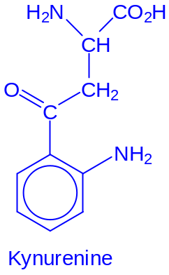

 for each correct structure
5 α-Halo carboxylic acids have the general structure

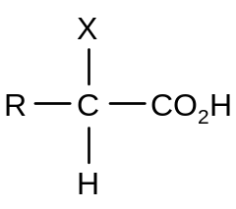 | X = Cl, Br, I

They are important intermediates in the synthesis of many organic compounds such as α-hydroxy acids and α-amino acids.

(a) The free radical chlorination of butanoic acid, CH₃CH₂CH₂CO₂H, gives a mixture of monochlorinated carboxylic acids. One of these is an α-chloro carboxylic acid.

(i) Draw the structures of all the monochlorinated products and suggest (with a reason) in what ratio they might be formed.

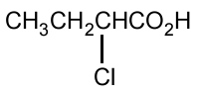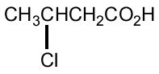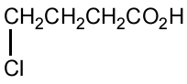
3 correct [2], 2 correct [1]

3:2:2; statistical ratio [1]

(ii) Outline the mechanism for the formation of the α-chloro carboxylic acid from butanoic acid, labelling each step in the mechanism appropriately.
[6]
Free radical substitution

Initiation [1]
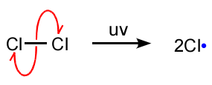
Propagation [1]

Termination [1]
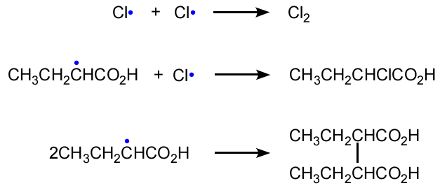
(b) A better method of synthesising α-bromo carboxylic acids and α-chloro carboxylic acids from carboxylic acids was discovered by three chemists, Carl Magnus von Hell (1849-1926), Jacob Volhard (1834-1910) and Nikolay Zelinsky (1861-1953).

For example, propanoic acid can be converted to 2-bromopropanoic acid in good yield via the Hell-Volhard-Zelinsky reaction (HVZ reaction).

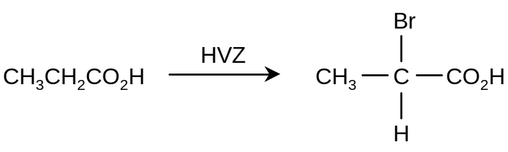

The HVZ reaction involves heating a carboxylic acid with bromine and a small amount of phosphorus tribromide, followed by treatment with water.

The reaction scheme below shows two of the intermediate compounds formed during the reaction.

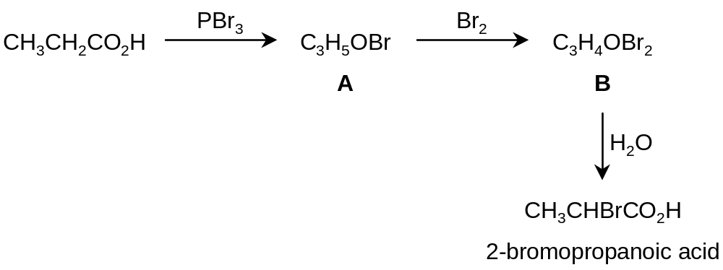

(i) Draw the structure of the product formed when 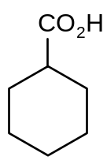 undergoes the HVZ reaction. [1]

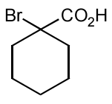

(ii) Draw the structures of A and B. [2]

A: CH₃CH₂COBr
B: CH₃CHBrCOBr

(c) The reaction mechanism for the Hell-Volhard-Zelinsky reaction in (b) consists of several steps. For the formation of 2-bromopropanoic acid, one of the steps in the mechanism involves the enol C shown below.

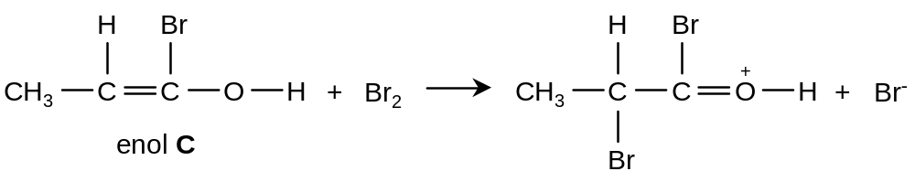

(i) Re-write the equation to show the movement of electrons for this step in the mechanism.

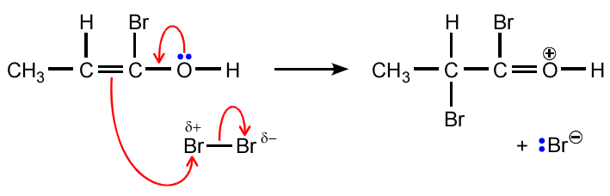
arrow from lone pair on O to C-O bond [1]
arrow from π bond to Br and
arrow from Br-Br bond to Br [1]

(ii) What is the role of bromine in this step? Explain your answer.
[3]

electrophile
Award mark only if explanation shows understanding

(d) Unlike free radical bromination, a good yield of an α-bromo carboxylic acid can be obtained from the corresponding carboxylic acid using the HVZ reaction in (b).

Each of the compounds D and E below can be synthesised from the respective starting material using the HVZ reaction in one of the steps of each synthesis. Suggest the reagents and conditions required for each transformation. In each case, identify all the intermediate compounds.

(i) 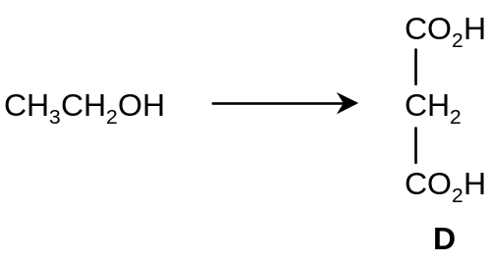
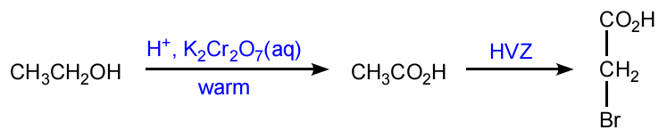
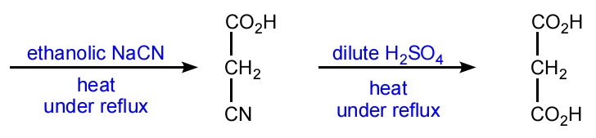

(ii) 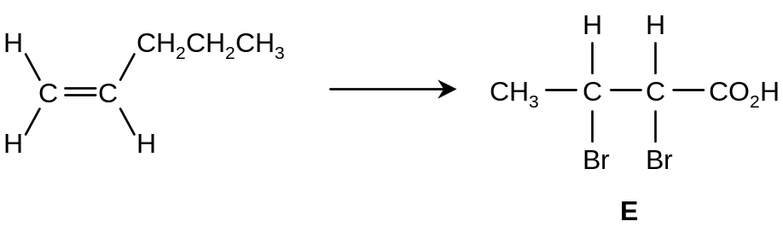

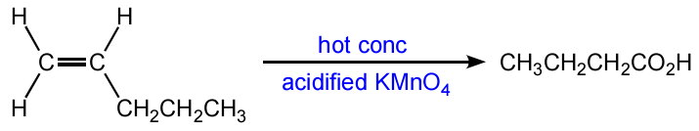

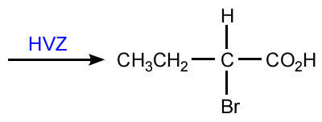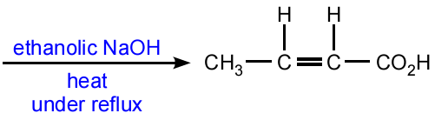

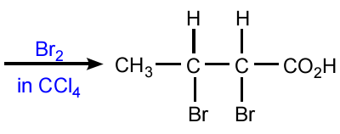

[8]

[Total: 20]

½Br

A

B

Solution B
pH = 9.76
Concentration = 0.150 mol dm⁻³
Solution A
pH = 12.5
Concentration = 0.0316 mol dm⁻³

C
Solution C
pH < 7.00
Concentration = 0.0316 mol dm⁻³

E

